Laboratory Tutorial #2 – PART-II

Roofline Model

* *Label each point (a)…(l) in the Roofline model (below) with the variant (1)…(12) of the table (also below)*

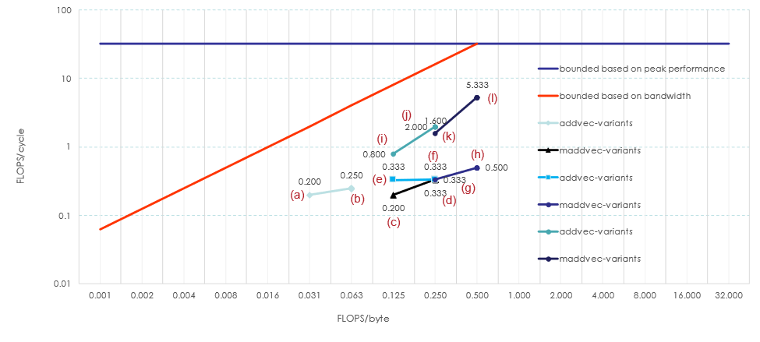

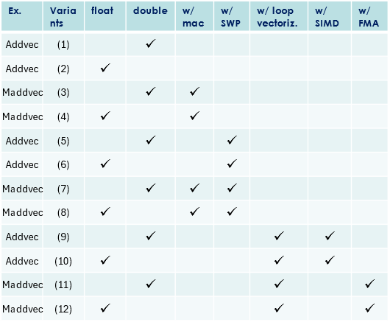

So, let’s make the connections between points and variants:

|  |  |  |
| --- | --- | --- |
| Points in Roofline Model |  | Variants |
| (a) |  | (1) |
| (b) |  | (2) |
| (c) |  | (3) |
| (d) |  | (4) |
| (e) |  | (5) |
| (f) |  | (6) |
| (g) |  | (7) |
| (h) |  | (8) |
| (i) |  | (9) |
| (j) |  | (10) |
| (k) |  | (11) |
| (l) |  | (12 |

Laboratory Tutorial #3

Code Transformations and Optimizations

Let’s fill the table below in a collaborative way with your colleagues.

**Table III. Examples of gcc compiler optimizations.**

|  |  |  |  |
| --- | --- | --- | --- |
| **Gcc optimization** | **Brief description** | **Possible parameters? (if yes, which ones?)** | **Identify in which optimization option, i.e., -=, -O1, -O2, -O3, -Ofast, -Ox, the optimization is included (e.g., check via gcc -Q --help=optimizers)** |
| -floop-unroll-and-jam |  |  |  |
| -ftree-loop-distribution |  |  |  |
| -floop-interchange |  |  |  |
| -funroll-loops |  |  |  |
| -funroll-all-loops |  |  |  |
| -ftree-loop-vectorize |  |  |  |
| -fno-tree-loop-optimise |  |  |  |
| -fmove-loop-invariants |  |  |  |
| -ffast-math |  |  |  |
| -funsafe-math-optimizations |  |  |  |
| -fcrossjumping flag |  |  |  |
| -fcse-follow-jumps |  |  |  |
| -fguess-branch-probability |  |  |  |
| -fno-guess-branch-probability |  |  |  |
| -ftree-ccp |  |  |  |
| -ftree-bit-ccp |  |  |  |
| -finline-functions |  |  |  |
| -fno-inline-functions |  |  |  |
| -fipa-icf |  |  |  |
| -fipa-vrp |  |  |  |
| -fipa-cp |  |  |  |